***GrainPalette: A Deep Learning Odyssey in Rice Type Classification Through Transfer Learning***

***Project Documentation***

**1. Introduction:-**

**Project Title:**  
GrainPalette – A Deep Learning Odyssey in Rice Type Classification Through Transfer Learning

**Team ID:** LTVIP2025TMID44435  
**Team Leader:** Thumbeti Usha Rani

**Team Members:** Shaik Asma,Potu Naga Malleswari,Tanguturi Manasa Lakshmi

**Overview:**  
GrainPalette is a deep learning-based web application for classifying rice varieties from images accurately identify rice types, helping farmers, millers, and exporters ensure rice quality.

**2. Project Overview**

**Purpose:-**  
To automate rice variety identification using image-based deep learning, reducing manual errors in rice grading.

**Key Features:-**

· Upload rice images for instant classification

· Displays confidence score for predictions

· Expandable to include rice disease detection

**3. System Architecture**

Frontend (HTML/CSS/JS + Flask/Jinja):

· HTML/CSS for static pages

**Backend (Flask + PyTorch):**

· REST endpoints for uploading and predicting rice images

· Pillow/OpenCV for image transformations

**4. Setup Instructions:**

**Prerequisites:**

· Python 3.9+

· pip

· virtualenv (recommended)

Installation & Setup:

# Clone repository

git clone https://github.com/your-username/grainpalette.git

# Setup virtual environment

cd grainpalette

python -m venv venv

venv\Scripts\activate # Windows

source venv/bin/activate # Linux/Mac

# Install dependencies

pip install -r requirements.txt

# Run the Flask server

python app.py

Frontend & Backend Terminals:-

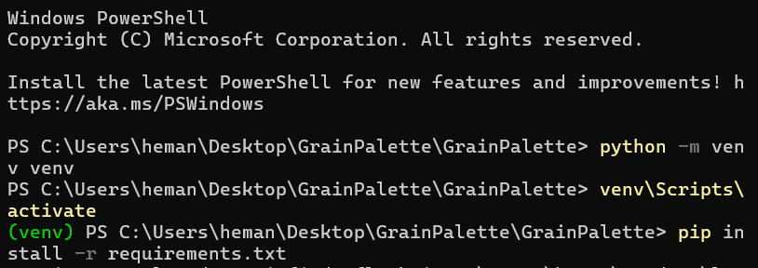

**5. Folder Structure :-**

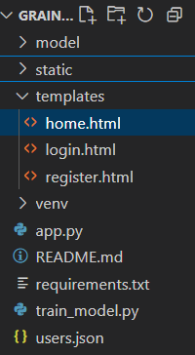**grainpalette/**

**├── app.py**

**├── /templates/**

**│ ├── login.html**

**│ ├── home.html**

**│ └── ...**

**├── /static/**

**│ ├── css/**

**│ ├── js/**

**│ └── images/**

**├── /model/**

**│ └── rice_classifier.pth**

**├── /utils/**

**│ └── preprocessing.py**

**└── requirements.txt**

**6. Running the Application**

**# Start the Flask server**

**python app.py**

**7. API Documentation**

|  |  |  |
| --- | --- | --- |
| **METHOD** | **ENDPOINT** | **DESCRIPTION** |
| **POST** | **/PREDICT** | **UPLOAD RICE IMAGE AND GET CLASSIFICATION** |
| **GET** | **/** | **HOME PAGE** |
| **GET** | **/ABOUT** | **ABOUT PROJECT** |
| **GET** | **/CONTACT** | **CONTACT US PAGE** |

**8. Testing**

**Tools Used:**

· Postman – For testing /predict endpoint

· Browser DevTools – Frontend inspection

· Pytest – Optional, for backend logic tests

**Testing Coverage:**

· Prediction accuracy tests with known images

· Upload validations

· Page rendering tests

**9. Known Issues**

· Limited dataset may affect rare rice types

· No user accounts or history in initial release

· No mobile app version yet

**10. Future Enhancements**

· Integrate rice disease detection module

· Add user account system with prediction history

· Support mobile app frontend

· Multi-language support for farmers

· Cloud deployment with API access

**11 .Conclusion**

GrainPalette offers a comprehensive deep learning solution for accurate rice variety classification. Delivered through a user-friendly web interface, this innovative system serves as a foundational step towards fully automating rice quality control, designed for scalable enhancements including disease detection and broader mobile platform accessibility.